**Technical Design Document (TDD)**

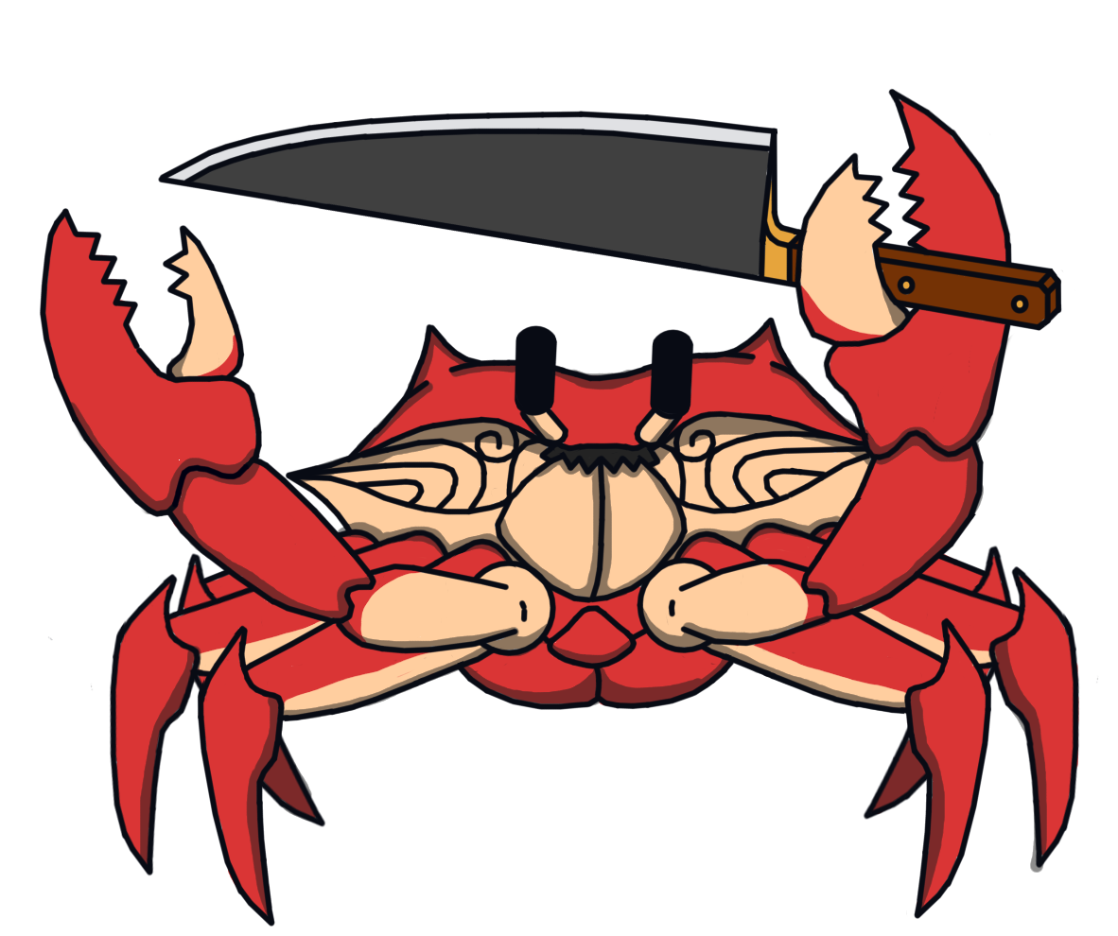

***‘Those are monsters are alright :D’*** - Doomers

**Table of Contents:**

1. Executive summary
   1. Game overview
   2. Technical Summary
2. Evaluation
   1. Game Engine
   2. Analysis
   3. Target Platform
3. Scheduling
   1. Development Plan
   2. Milestone
4. Work Environment
5. File format and Naming
6. Levels

|  |
| --- |
|  |
| a) |

1. Executive summary

a) Game Overview

Description: A turn based rogue-like rpg that pits giant kaiju monsters in a battle of island supremacy. The player can select which monsters they would like to use to combat other monsters. The game uses 2D elements in a 3D setting. The monster will keep fighting in different islands until the player’s monster character perishes.

b) Technical Summary

Game developed by a team of 4. Game features procedurally generated terrain, cool amp ui implementing boids and 2d style in a 3D world.

2. Evaluation

a) Game Engine

The game engine used is Unity.

b) Analysis

Terrain is procedurally generated at the start of the scene. No hang ups on there currently.

Had some issues in the pcg_mesh of the water effect in the battle scene. The scene was lagging/stuttering due to the large amount of generated vertices needed.

-Fixed this by reducing the the number of vertices generated and scaled the water accordingly to the size of our battle scene

c) Target Platforms

* PC
* MAC

3. Scheduling

a) Development Plan

Created a basic UI  
 Implement a PCG terrain map & Boids

Create a character selection

Implement a battle system

b) Milestone

* Creation of the Game - 17 Apr, 2020
* Added Artwork - 20 Apr, 2020
* Created Fight Scene - 21 Apr, 2020
* Terrain Creation - 28 Apr, 2020
* Boids Completion - 4 May, 2020
* Completed the Game - 5 May, 2020
* GDD & TDD Finished - 5 May, 2020

4. Work Environment

At home mostly due to the current crisis of the corona virus and stay-at-home orders. Many distractions present and lack of true privacy to focus. Communication done through discord.

5. File Format & Naming

|  |  |  |  |  |
| --- | --- | --- | --- | --- |
| Asset Type | Subtype | Naming  Convention | File Format | Annotations |
| 2D Asset | Characters  NPC  Environment  Icons  Consumable | Angler  TempBoid#  BattleGround  Random Monster  TunaFish | PNG  PNG  PNG  PNG  PNG |  |
| 3D Assets | Environment | Mountain | PREFAB | PCG Terrain |
| Animations |  | CrabSpecial | ANIM | Idle  Attack  Defense  Heal  Special Attack |
| Textures |  | Rock Layer | TERRAINLAYER |  |
| Scripts | Boids  UI  Fighting  Characters | IndvShip  UI_Credits  RPG_Unit  MonsterInfo | C#  C#  C#  C# | Circletree  Main Menu, etc. |
| PCG/AI | Boids  Terrain | TempBoid#  Mountain | PNG  PREFAB |  |
| Materials |  | Water | *.mat | Water game object |
| UI |  | UI_Credits | C# |  |

6. Levels

The level contains boids of sprite of birds that will swarm around their own encounters to indicate the oncoming monster battle. Five encounters will randomly generate within the collection of islands and since the battles are on the scenes, soon as they touch land they are deleted. Therefore, encounters will range a total of 1-5 per generation of islands. The encounters are clickable objects that players may click in order to start a fight.